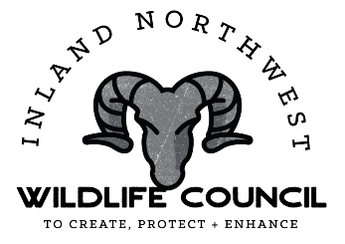
Inland Empire Paper Company - Disabled Hunter Program
The Inland Empire Paper Co. (IEPC) has donated 25 family access permits to the Inland Northwest Wildlife Council (INWC) to be awarded through a drawing for Hunters with a Disability. To apply for the drawing, please fill out the following:
Name ____________________________________________ Phone_______________________
Address_______________________________________________________________________
City ________________________________________ State ______________ Zip ___________
Wild ID ________________________________ Email _________________________________

Applications will be accepted from March 1, 2023 thru April 15th, 2023.
The drawing will be held on Friday, April 21st, 2023 and winners will be notified within 5 days. If you cannot or choose not to use the access permit awarded, please return it to INWC so an alternate hunter with a disability may use it.
All Fish & Wildlife hunting rules and regulations must be followed, and all Inland Empire Paper Company access rules and regulations must be followed. Persons who violate any hunting or access rules as specified above will be removed from the program, mailings, and future opportunities.
All applications must be returned by April 15th, 2023 to the following address: Inland Northwest Wildlife Council, 6116 North Market, Spokane, Washington 99208. Please visit the INWC website for more information at: www.wildlifecouncil.com Applications can be printed from the WDFW website: www.wdfw.wa.gov/accessibility
If you have any questions, please call WDFW Region 1 ADAAC Representative,
Ken McNaughton, at 509-553-9135.

